Optimized BI-LSTM and Genetic Algorithm-Based Extreme Learning Machine Framework for Air Quality Forecasting

INTRODUCTION
Air pollution is a prevalent environmental problem in the twenty-first century. In light of the rapid industrialization and urbanization, air pollution is getting worse, which greatly affects our living environment and health. Li et al. concluded that outdoor physical activity poses numerous health risks due to ambient air pollution in China. According to the Chinese Ambient Air Quality Standards (GB3095- 2012), there are six conventional air pollutants used to measure air quality: sulfur dioxide (SO2), nitrogen dioxide (NO2), particulate matter with a particle size less than 10 microns (PM10), particulate matter with a particle size less than 2.5 microns (PM2.5), ozone (O3), and carbon monoxide (CO). These pollutants have adverse effects on human health. The International Energy Agency estimates that air pollution causes 6.5 million premature deaths per year, while long-term exposure to pollutants, such as fine particles (e.g., PM2.5) or traffic-related pollutants, is linked to higher rates of lung cancer, coronary heart disease, and other illnesses. Therefore, studies on air quality prediction are particularly important and are considered a key factor for environmental protection. In order to more comprehensively assess the health effects of air pollution, numerous air quality monitoring stations have been set up in major cities. Air quality predictions can be made based on the data collected from these stations. Air VOLUME 4, 2016 1 This article has been accepted for publication in IEEE Access. This is the author's version which has not been fully edited and content may change prior to final publication. Citation information: DOI 10.1109/ACCESS.2023.3291146 This work is licensed under a Creative Commons Attribution-Noncommercial-No Derivatives 4.0 License. For more information, see https://creativecommons.org/licenses/by-nc-nd/4.0/ Author et al.: Preparation of Papers for IEEE TRANSACTIONS and JOURNALS quality monitoring, modeling, and accurate predictions are important for having a clear understanding of future pollution levels and their associated health risks. Recently, the inherent property of machine learning algorithms to automatically learn features at multiple levels of abstraction has become increasingly important in providing solutions to this challenging task. However, the model only forecasts PM10 and SO2 levels, and it is also challenging to obtain measurement values needed to construct the dataset. Wu Q. et al. proposed an optimal-hybrid model for daily AQI prediction considering air pollutant factors, with the model’s inputs being the six atmospheric pollutants. However, neural networks typically struggle with slow learning, a tendency to fall into local minima, and a complex network training process. Based on the generalized inverse matrix theory, Huang et al. proposed an extreme learning machine (ELM) algorithm with a feedforward neural network that includes a single hidden layer, such that the problems of conventional neural network algorithms are circumvented. The ELM algorithm used to predict the AQI outperformed neural networks in terms of parameter selection, training speed, and prediction accuracy. However, the parameters of the hidden layer nodes and the number of nodes in the test hidden layer are selected at random, which puts the prediction accuracy to a great test. In order to solve the aforementioned problems, we propose to optimize the number of ELM hidden layer nodes, thresholds, and weights, along with an improved genetic algorithm (GA) that uses root mean square error (RMSE) as the fitness function, to obtain the optimal network structure for air quality prediction. The number of hidden layer nodes is updated by continuous coding discretization, the input weights and hidden layer thresholds are updated by continuous coding, and the update thresholds and weights are selected with the number of updated layers to form a hierarchical control structure. The proposed GA-based improved extreme learning machine (GA-KELM) algorithm is applied to air quality prediction, and its performance is compared with that of community multiscale air quality modeling system (CMAQ), support vector regression (SVR), and deep belief network-back propagation (DBN-BP). The results show that the accuracy of the proposed GA-KELM algorithm is reliable for air quality prediction. In this study, an improved extreme learning machine model based on a genetic algorithm is designed and applied to AQI prediction. To verify the effectiveness of the model, we conducted tests on three real-world datasets. The results confirmed that the proposed method has superior performance and outperforms some advanced methods currently in use. The main contributions of this paper are: modifying the ELM activation function or using the kernel function to improve the prediction accuracy, optimizing the ELM using GA to improve the stability of the results and further enhance the prediction accuracy, andobtaining the correlation analysis results of atmospheric environmental quality prediction parameters by comprehensively considering each relevant factor in line with the actual situation. The remainder of this paper is organized as follows. Section 2 presents related work. Section 3 describes ELM and the proposed GA-KELM, and illustrates the improvements using the model. Section 4 discusses experimental results where GA-KELM is compared with several other methods in terms of prediction results. The last section concludes the entire work and presents directions for future research.
1.1 Objective of the project:
This study proposes an advanced and robust air quality forecasting framework that integrates a Genetic Algorithm–optimized Kernel Extreme Learning Machine (GA-KELM) with Bidirectional Long Short-Term Memory (BI-LSTM) networks to achieve highly accurate PM2.5 concentration predictions. The Genetic Algorithm is employed to automatically optimize the kernel parameters and hidden layer configurations of the KELM model, enabling efficient feature selection and minimizing prediction error. To further enhance temporal learning, the BI-LSTM component captures both past and future dependencies in air quality time-series data by processing information in forward and backward directions. This bidirectional learning mechanism effectively refines feature weights and preserves long-range temporal correlations, leading to improved representation of complex pollution patterns.
The proposed hybrid framework is evaluated using real-world PM2.5 air quality datasets and benchmarked against conventional machine learning models such as standard Extreme Learning Machine (ELM) and Support Vector Machine (SVM). Performance evaluation using error metrics including Mean Squared Error (MSE) and Root Mean Squared Error (RMSE) demonstrates a significant reduction in prediction errors, confirming the superiority of the hybrid GA-KELM–BI-LSTM approach. Experimental results highlight the model’s enhanced predictive accuracy, stability, and robustness under varying pollution conditions, making it well-suited for real-time air quality monitoring, early pollution warning systems, and data-driven environmental decision-making.
2. LITERATURE SURVEY:
A Bayesian LSTM model to evaluate the effects of air pollution control regulations in China
Rapid socio-economic development and urbanization have resulted in serious deterioration in air-quality in many world cities, including Beijing, China. This study attempts to examine the effectiveness of air pollution control regulations implemented in Beijing during 2008–2019 through a data-driven regulatory intervention analysis. Our proposed Bayesian deep learning model utilizes proxy data including Aerosol Optical Depth (AOD) and meteorology as well as socio-economic data, while accounting for confounding effects via propensity score estimation. Our results show that air pollution control regulatory measures implemented in China and Beijing during 2008–2019 reduced PM2.5 pollution in Beijing by 11 % on average. After the introduction of Action Plan for Clean Air in China and Beijing in late 2013, as compared to the hypothetical PM2.5 concentration (without any regulatory interventions), the estimated PM2.5 reduction increased dramatically from 15 % in 2015 to 44 % in 2018. Our results suggest that Beijing’s air quality has improved gradually over the past decade, though the annual PM2.5 pollution still exceeds the WHO threshold. In this regard, the air pollution control regulations introduced in Beijing and China tend to become more effective after 2015, suggesting a 2-year time lag before the stringent air pollution control regulations starting from 2013 takes any strong positive effects. Moreover, as compared to the air pollution control regulations introduced before 2013, newly introduced policy-making governance, which couples the policy-makings of the local jurisdictions with that of the central government, and the new policy measures that tackle the vested interests of the local stakeholders in Beijing and its nearby cities, alongside with the stringent local and national air pollution control regulations and plans, should help reduce air pollution and promote healthy living in Beijing over the longer term.
Air pollution forecasts: An overview
Air pollution is defined as a phenomenon harmful to the ecological system and the normal conditions of human existence and development when some substances in the atmosphere exceed a certain concentration. In the face of increasingly serious environmental pollution problems, scholars have conducted a significant quantity of related research, and in those studies, the forecasting of air pollution has been of paramount importance. As a precaution, the air pollution forecast is the basis for taking effective pollution control measures, and accurate forecasting of air pollution has become an important task. Extensive research indicates that the methods of air pollution forecasting can be broadly divided into three classical categories: statistical forecasting methods, artificial intelligence methods, and numerical forecasting methods. More recently, some hybrid models have been proposed, which can improve the forecast accuracy. To provide a clear perspective on air pollution forecasting, this study reviews the theory and application of those forecasting models. In addition, based on a comparison of different forecasting methods, the advantages and disadvantages of some methods of forecasting are also provided. This study aims to provide an overview of air pollution forecasting methods for easy access and reference by researchers, which will be helpful in further studies.
A Deep Learning Approach to Writer Identification Using Inertial Sensor Data of Air-Handwriting
To the best of our knowledge, there are a few researches on air-handwriting character-level writer identification only employing acceleration and angular velocity data. In this paper, we propose a deep learning approach to writer identification only using inertial sensor data of air-handwriting. In particular, we separate different representations of degree of freedom (Doff) of air-handwriting to extract local dependency and interrelationship in different CNNs separately. Experiments on a public dataset achieve an average good performance without any extra hand-designed feature extractions.
Application of computational intelligence techniques to forecast daily PM10 exceedances in Brunei Darussalam
Particulate matter (PM₁₀) is the pollutant causing exceedances of ambient air quality thresholds, and the key indicator of air quality index in Brunei Darussalam for haze related episodes caused by the recurrent biomass fires in Southeast Asia. The present study aims at providing suitable forecasts for PM₁₀ exceedances to aid in health advisory during haze episodes at the four administrative districts of the country. A framework based on random forests (RFs), genetic algorithm (GA) and back propagation neural networks (BPNN) computational intelligence techniques has been proposed in which the final prediction is made by the BPNN model. A hybrid combination of GA and RFs is initially applied to determine optimal set of inputs from the initial data sets of largely available meteorological, persistency of high pollution levels, short- and long-term variations of emissions rates parameters. The inputs selection procedure does not depend on the back propagation training algorithm. The numerical results presented in this paper show that the proposed model not only produced satisfactory forecasts but also consistently performed better via several statistical performance indicators when compared with the standard BPNN and GA optimization based on back propagation training algorithm. The model also showed satisfactory threshold exceedances forecasts achieving for instance best true predicted rate of 0.800, false positive rate of 0.014, false alarm rate of 0.333 and success index of 0.786 at Brunei-Maura district monitoring station. Overall, the current study has profound implications on future studies to develop a real-time air quality forecasting system to support haze management.
Optimization on fresh outdoor air ratio of air conditioning system with stratum venti-lotion for both targeted indoor air quality and maximal energy saving
Stratum ventilation can energy efficiently provide good inhaled indoor air quality with a proper operation (e.g., fresh outdoor air ratio). However, the non-uniform CO₂ distribution in a stratum-ventilated room challenges the provision of targeted indoor air quality. This study proposes an optimization on the fresh outdoor air ratio of stratum ventilation for both the targeted indoor air quality and maximal energy saving. A model of CO₂ concentration in the breathing zone is developed by coupling CO₂ removal efficiency in the breathing zone and mass conservation laws. With the developed model, the ventilation parameters corresponding to different fresh outdoor air ratios are quantified to achieve the targeted indoor air quality (i.e., targeted CO₂ concentration in the breathing zone). Using the fresh outdoor air ratios and corresponding ventilation parameters as inputs, energy performance evaluations of the air conditioning system are conducted by building energy simulations. The fresh outdoor air ratio with the minimal energy consumption is determined as the optimal one. Experiments show that the mean absolute error of the developed model of CO₂ concentration in the breathing zone is 1.9%. The effectiveness of the proposed optimization is demonstrated using TRNSYS that the energy consumption of the air conditioning system with stratum ventilation is reduced by 6.4% while achieving the targeted indoor air quality. The proposed optimization is also promising for other ventilation modes for targeted indoor air quality and improved energy efficiency.
Deep air quality forecasting using hybrid deep learning framework
Air quality forecasting has been regarded as the key problem of air pollution early warning and control management. In this article, we propose a novel deep learning model for air quality (mainly PM2.5) forecasting, which learns the spatial-temporal correlation features and interdependence of multivariate air quality related time series data by hybrid deep learning architecture. Due to the nonlinear and dynamic characteristics of multivariate air quality time series data, the base modules of our model include one-dimensional Convolutional Neural Networks (1D-CNNs) and Bi-directional Long Short-term Memory networks (Bi-LSTM). The former is to extract the local trend features and spatial correlation features, and the latter is to learn spatial-temporal dependencies. Then we design a jointly hybrid deep learning framework based on one-dimensional CNNs and Bi-LSTM for shared representation features learning of multivariate air quality related time series data. We conduct extensive experimental evaluations using two real-world datasets, and the results show that our model is capable of dealing with PM2.5 air pollution forecasting with satisfied accuracy.
3. SYSTEM ANALYSIS
3.1 Existing System
The existing air quality forecasting systems mainly rely on traditional machine learning models such as Support Vector Machine (SVM) and standard Extreme Learning Machine (ELM). These models use manually tuned parameters and unidirectional learning approaches, which limits their ability to capture complex nonlinear relationships and long-term temporal dependencies in PM2.5 time-series data. As a result, prediction accuracy and robustness decrease, especially under rapidly changing environmental conditions.
Disadvantages
- Limited prediction accuracy due to manual parameter tuning and shallow learning models.
- Inability to capture long-term and bidirectional temporal dependencies in air quality data.
Higher MSE and RMSE values under dynamic and non-linear pollution patterns.
PROPOSED SYSTEM
The proposed system introduces a hybrid GA-KELM and BI-LSTM framework for advanced air quality forecasting. The Genetic Algorithm optimizes the KELM parameters for effective feature selection, while the Bidirectional LSTM captures both past and future temporal dependencies to refine feature weights. This integrated approach significantly reduces prediction errors and enhances accuracy, robustness, and adaptability for real-time PM2.5 monitoring and decision support.
Advantages
- Improved forecasting accuracy through GA-optimized KELM and bidirectional temporal learning.
- Effective handling of nonlinear and time-dependent PM2.5 variations using BI-LSTM.
- Reduced prediction errors (lower MSE and RMSE) with higher robustness for real-time monitoring.
Modules Information:
To implement this project we have used same dataset given in your requirement file and to implement this project we have designed following modules
- defining interpolate function: using this module to deal with missing values and outliers.
- training SVM algorithm: using this module we trained svm. In graph, Red line represents Original Test Air Quality and Predicted Air Quality
- training propose genetic ELM: using this module we trained genetic elm called GA-KELM
- training extension BI-LSTM algorithm: using this module, we trained bi-lstm algorithm
FUNCTIONAL REQUIREMENTS:
SOFTWARE REQIREMENTS:
System Atributes:
- Filename
- dataset
- X, Y, mse, X_train, X_test, y_train, y_test
Prototype:
python 3.7.0 or 3.7.4
opencv-python==4.5.1.48
keras==2.3.1
tensorflow==1.14.0
protobuf==3.16.0
h5py==2.10.0
sklearn-extensions==0.0.2
scikit-learn==0.22.2.post1
Numpy
Pandas
NON-FUNCTIONAL REQUIREMENT:
Usability: Usability is a quality attribute that assesses how easy user interfaces are to use. The word "usability" also refers to methods for improving ease-of-use during the design process.(how it was handle entire project easy)
Security:the quality or state of being secure: such as. a : freedom from danger : safety. b : freedom from fear or anxiety. c : freedom from the prospect of being laid off job security.
Readability: Readability is the ease with which a reader can understand a written text.
Performance: the execution of an action. : something accomplished : deed, feat. : the fulfillment of a claim, promise, or request : implementation. 3. : the action of representing a character in a play.
Availability: the quality or state of being available trying to improve the availability of affordable housing. 2 : an available person or thing.
Scalability: Scalability is the measure of a system's ability to increase or decrease in performance and cost in response to changes in application and system processing demands.

3.3. PROCESS MODEL USED WITH JUSTIFICATION
SDLC (Umbrella Model):
Umbrella Activity
Umbrella Activity
Umbrella Activity
- Feasibility Study
- TEAM FORMATION
- Project Specification PREPARATION

Business Requirement Documentation
ANALYSIS & DESIGN
CODE
UNIT TEST
DOCUMENT CONTROL

ASSESSMENT

TRAINING
INTEGRATION & SYSTEM TESTING

DELIVERY/INSTALLATION
ACCEPTANCE TEST
Requirements Gathering
SDLC is nothing but Software Development Life Cycle. It is a standard which is used by software industry to develop good software.
Stages in SDLC:
- Requirement Gathering
- Analysis
- Designing
- Coding
- Testing
- Maintenance

Requirements Gatheringstage:
The requirements gathering process takes as its input the goals identified in the high-level requirements section of the project plan. Each goal will be refined into a set of one or more requirements. These requirements define the major functions of the intended application, define operational data areas and reference data areas, and define the initial data entities. Major functions include critical processes to be managed, as well as mission critical inputs, outputs and reports. A user class hierarchy is developed and associated with these major functions, data areas, and data entities. Each of these definitions is termed a Requirement. Requirements are identified by unique requirement identifiers and, at minimum, contain a requirement title and textual description.
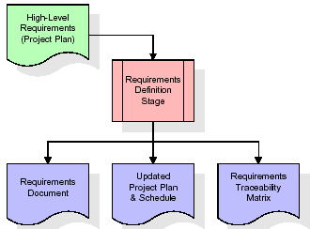
These requirements are fully described in the primary deliverables for this stage: the Requirements Document and the Requirements Traceability Matrix (RTM). The requirements document contains complete descriptions of each requirement, including diagrams and references to external documents as necessary. Note that detailed listings of database tables and fields are not included in the requirements document.
The title of each requirement is also placed into the first version of the RTM, along with the title of each goal from the project plan. The purpose of the RTM is to show that the product components developed during each stage of the software development lifecycle are formally connected to the components developed in prior stages.
In the requirements stage, the RTM consists of a list of high-level requirements, or goals, by title, with a listing of associated requirements for each goal, listed by requirement title. In this hierarchical listing, the RTM shows that each requirement developed during this stage is formally linked to a specific product goal. In this format, each requirement can be traced to a specific product goal, hence the term requirements traceability.
The outputs of the requirements definition stage include the requirements document, the RTM, and an updated project plan.
- Feasibility study is all about identification of problems in a project.
- No. of staff required to handle a project is represented as Team Formation, in this case only modules are individual tasks will be assigned to employees who are working for that project.
- Project Specifications are all about representing of various possible inputs submitting to the server and corresponding outputs along with reports maintained by administrator.
Analysis Stage:
The planning stage establishes a bird's eye view of the intended software product, and uses this to establish the basic project structure, evaluate feasibility and risks associated with the project, and describe appropriate management and technical approaches.
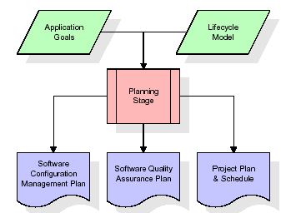
The most critical section of the project plan is a listing of high-level product requirements, also referred to as goals. All of the software product requirements to be developed during the requirements definition stage flow from one or more of these goals. The minimum information for each goal consists of a title and textual description, although additional information and references to external documents may be included. The outputs of the project planning stage are the configuration management plan, the quality assurance plan, and the project plan and schedule, with a detailed listing of scheduled activities for the upcoming Requirements stage, and high level estimates of effort for the out stages.
Designing Stage:
The design stage takes as its initial input the requirements identified in the approved requirements document. For each requirement, a set of one or more design elements will be produced as a result of interviews, workshops, and/or prototype efforts. Design elements describe the desired software features in detail, and generally include functional hierarchy diagrams, screen layout diagrams, tables of business rules, business process diagrams, pseudo code, and a complete entity-relationship diagram with a full data dictionary. These design elements are intended to describe the software in sufficient detail that skilled programmers may develop the software with minimal additional input.
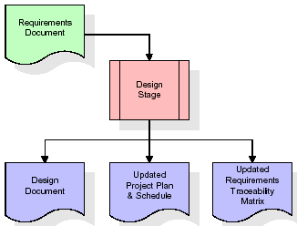
When the design document is finalized and accepted, the RTM is updated to show that each design element is formally associated with a specific requirement. The outputs of the design stage are the design document, an updated RTM, and an updated project plan.
Development (Coding) Stage:
The development stage takes as its primary input the design elements described in the approved design document. For each design element, a set of one or more software artifacts will be produced. Software artifacts include but are not limited to menus, dialogs, and data management forms, data reporting formats, and specialized procedures and functions. Appropriate test cases will be developed for each set of functionally related software artifacts, and an online help system will be developed to guide users in their interactions with the software.
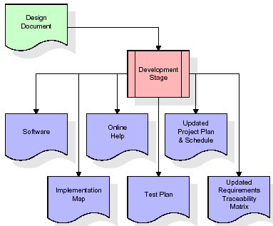

The RTM will be updated to show that each developed artifact is linked to a specific design element, and that each developed artifact has one or more corresponding test case items. At this point, the RTM is in its final configuration. The outputs of the development stage include a fully functional set of software that satisfies the requirements and design elements previously documented, an online help system that describes the operation of the software, an implementation map that identifies the primary code entry points for all major system functions, a test plan that describes the test cases to be used to validate the correctness and completeness of the software, an updated RTM, and an updated project plan.
Integration & Test Stage:
During the integration and test stage, the software artifacts, online help, and test data are migrated from the development environment to a separate test environment. At this point, all test cases are run to verify the correctness and completeness of the software. Successful execution of the test suite confirms a robust and complete migration capability. During this stage, reference data is finalized for production use and production users are identified and linked to their appropriate roles. The final reference data (or links to reference data source files) and production user list are compiled into the Production Initiation Plan.
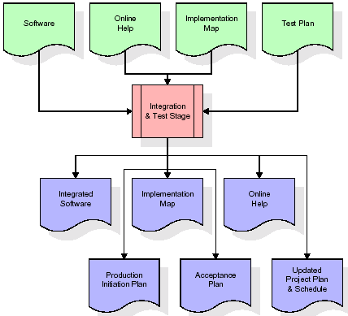
The outputs of the integration and test stage include an integrated set of software, an online help system, an implementation map, a production initiation plan that describes reference data and production users, an acceptance plan which contains the final suite of test cases, and an updated project plan.
- Installation & Acceptance Test:
During the installation and acceptance stage, the software artifacts, online help, and initial production data are loaded onto the production server. At this point, all test cases are run to verify the correctness and completeness of the software. Successful execution of the test suite is a prerequisite to acceptance of the software by the customer.
After customer personnel have verified that the initial production data load is correct and the test suite has been executed with satisfactory results, the customer formally accepts the delivery of the software.
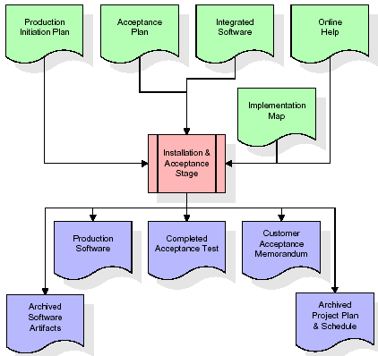
The primary outputs of the installation and acceptance stage include a production application, a completed acceptance test suite, and a memorandum of customer acceptance of the software. Finally, the PDR enters the last of the actual labor data into the project schedule and locks the project as a permanent project record. At this point the PDR "locks" the project by archiving all software items, the implementation map, the source code, and the documentation for future reference.

Maintenance:
Outer rectangle represents maintenance of a project, Maintenance team will start with requirement study, understanding of documentation later employees will be assigned work and they will undergo training on that particular assigned category. For this life cycle there is no end, it will be continued so on like an umbrella (no ending point to umbrella sticks).
3.4. Software Requirement Specification
3.4.1. Overall Description
A Software Requirements Specification (SRS) – a requirements specification for a software system is a complete description of the behavior of a system to be developed. It includes a set of use cases that describe all the interactions the users will have with the software. In addition to use cases, the SRS also contains non-functional requirements. Nonfunctional requirements are requirements which impose constraints on the design or implementation (such as performance engineering requirements, quality standards, or design constraints).
System requirements specification: A structured collection of information that embodies the requirements of a system. A business analyst, sometimes titled system analyst, is responsible for analyzing the business needs of their clients and stakeholders to help identify business problems and propose solutions. Within the systems development lifecycle domain, the BA typically performs a liaison function between the business side of an enterprise and the information technology department or external service providers. Projects are subject to three sorts of requirements:
- Business requirements describe in business terms what must be delivered or accomplished to provide value.
- Product requirements describe properties of a system or product (which could be one of several ways to accomplish a set of business requirements.)
- Process requirements describe activities performed by the developing organization. For instance, process requirements could specify .Preliminary investigation examine project feasibility, the likelihood the system will be useful to the organization. The main objective of the feasibility study is to test the Technical, Operational and Economical feasibility for adding new modules and debugging old running system. All system is feasible if they are unlimited resources and infinite time. There are aspects in the feasibility study portion of the preliminary investigation:
- ECONOMIC FEASIBILITY
A system can be developed technically and that will be used if installed must still be a good investment for the organization. In the economical feasibility, the development cost in creating the system is evaluated against the ultimate benefit derived from the new systems. Financial benefits must equal or exceed the costs. The system is economically feasible. It does not require any addition hardware or software. Since the interface for this system is developed using the existing resources and technologies available at NIC, There is nominal expenditure and economical feasibility for certain.
- Operational Feasibility
Proposed projects are beneficial only if they can be turned out into information system. That will meet the organization’s operating requirements. Operational feasibility aspects of the project are to be taken as an important part of the project implementation. This system is targeted to be in accordance with the above-mentioned issues. Beforehand, the management issues and user requirements have been taken into consideration. So there is no question of resistance from the users that can undermine the possible application benefits. The well-planned design would ensure the optimal utilization of the computer resources and would help in the improvement of performance status.
- TECHNICAL FEASIBILITY
Earlier no system existed to cater to the needs of ‘Secure Infrastructure Implementation System’. The current system developed is technically feasible. It is a web-based user interface for audit workflow at NIC-CSD. Thus, it provides an easy access to. the users. The database’s purpose is to create, establish and maintain a workflow among various entities in order to facilitate all concerned users in their various capacities or roles. Permission to the users would be granted based on the roles specified. Therefore, it provides the technical guarantee of accuracy, reliability and security.
3.4.2. External Interface Requirements
User Interface
The user interface of this system is a user friendly python Graphical User Interface.
Hardware Interfaces
The interaction between the user and the console is achieved through python capabilities.
Software Interfaces
The required software is python.
SYSTEM REQUIREMENT:
HARDWARE REQUIREMENTS:

Processor - Intel i3(min)
- Speed - 1.1 GHz
- RAM - 4GB(min)
- Hard Disk - 500 GB
SOFTWARE REQUIREMENTS:
- Operating System - Windows10(min)
- Programming Language - Python

4. SYSTEM DESIGN
CLASS DIAGRAM:
The class diagram is the main building block of object-oriented modeling. It is used both for general conceptual modeling of the systematic of the application, and for detailed modeling translating the models into programming code. Class diagrams can also be used for data modeling. The classes in a class diagram represent both the main objects, interactions in the application and the classes to be programmed. In the diagram, classes are represented with boxes which contain three parts:
- The upper part holds the name of the class
- The middle part contains the attributes of the class
- The bottom part gives the methods or operations the class can take or undertake
USECASE DIAGRAM:
A use case diagram at its simplest is a representation of a user's interaction with the system and depicting the specifications of a use case. A use case diagram can portray the different types of users of a system and the various ways that they interact with the system. This type of diagram is typically used in conjunction with the textual use case and will often be accompanied by other types of diagrams as we

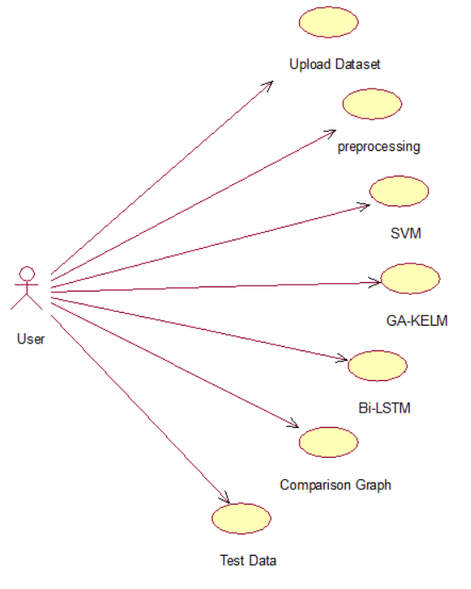

SEQUENCE DIAGRAM
A sequence diagram is a kind of interaction diagram that shows how processes operate with one another and in what order. It is a construct of a Message Sequence Chart. A sequence diagram shows object interactions arranged in time sequence. It depicts the objects and classes involved in the scenario and the sequence of messages exchanged between the objects needed to carry out the functionality of the scenario. Sequence diagrams are typically associated with use case realizations in the Logical View of the system under development. Sequence diagrams are sometimes called event diagrams, event scenarios, and timing diagrams.

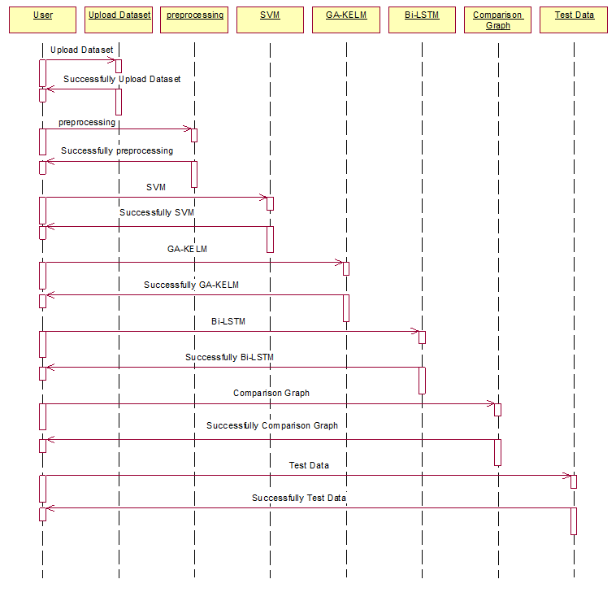

COLLABORATION DIAGRAM:
A collaboration diagram describes interactions among objects in terms of sequenced messages. Collaboration diagrams represent a combination of information taken from class, sequence, and use case diagrams describing both the static structure and dynamic behaviour of a system.

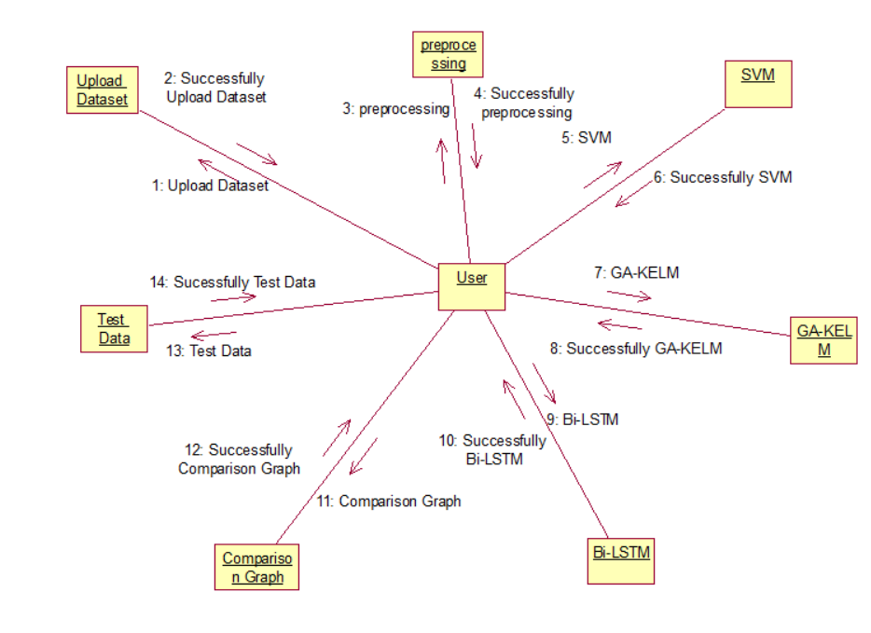

COMPONENT DIAGRAM:
In the Unified Modelling Language, a component diagram depicts how components are wired together to form larger components and or software systems. They are used to illustrate the structure of arbitrarily complex systems.
Components are wired together by using an assembly connector to connect the required interface of one component with the provided interface of another component. This illustrates the service consumer - service provider relationship between the two components.
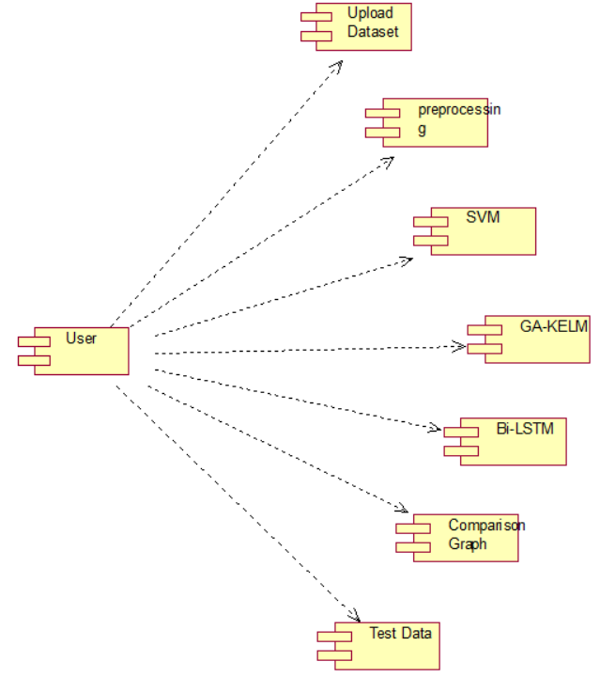

DEPLOYMENT DIAGRAM:
A deployment diagram in the Unified Modeling Language models the physical deployment of artifacts on nodes. To describe a web site, for example, a deployment diagram would show what hardware components ("nodes") exist (e.g., a web server, an application server, and a database server), what software components ("artifacts") run on each node (e.g., web application, database), and how the different pieces are connected (e.g. JDBC, REST, RMI).
The nodes appear as boxes, and the artifacts allocated to each node appear as rectangles within the boxes. Nodes may have sub nodes, which appear as nested boxes. A single node in a deployment diagram may conceptually represent multiple physical nodes, such as a cluster of database servers.
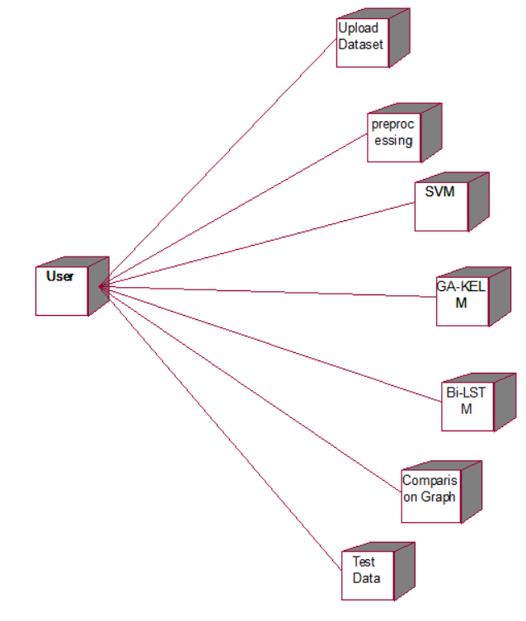

ACTIVITY DIAGRAM:
Activity diagram is another important diagram in UML to describe dynamic aspects of the system. It is basically a flow chart to represent the flow form one activity to another activity. The activity can be described as an operation of the system. So the control flow is drawn from one operation to another. This flow can be sequential, branched or concurrent
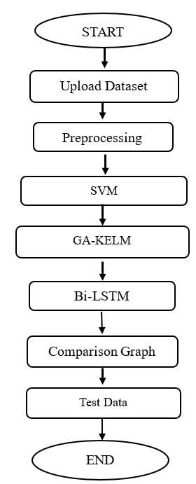
Data flow:
Data flow diagrams illustrate how data is processed by a system in terms of inputs and outputs. Data flow diagrams can be used to provide a clear representation of any business function. The technique starts with an overall picture of the business and continues by analyzing each of the functional areas of interest. This analysis can be carried out in precisely the level of detail required. The technique exploits a method called top-down expansion to conduct the analysis in a targeted way.
As the name suggests, Data Flow Diagram (DFD) is an illustration that explicates the passage of information in a process. A DFD can be easily drawn using simple symbols. Additionally, complicated processes can be easily automated by creating DFDs using easy-to-use, free downloadable diagramming tools. A DFD is a model for constructing and analyzing information processes. DFD illustrates the flow of information in a process depending upon the inputs and outputs. A DFD can also be referred to as a Process Model. A DFD demonstrates business or technical process with the support of the outside data saved, plus the data flowing from the process to another and the end results.

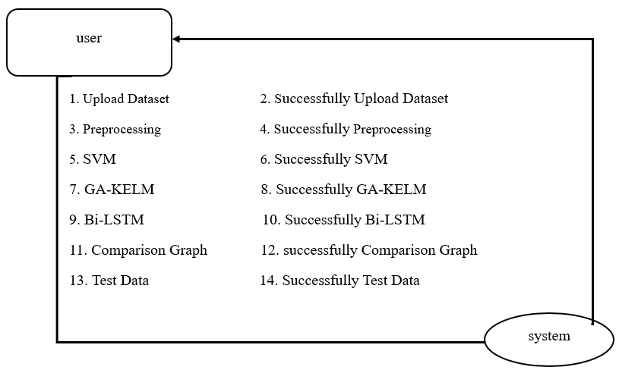
5. IMPLEMETATION
5.1 python
One of the most popular languages is Python. Guido van Rossum released this language in 1991. Python is available on the Mac, Windows, and Raspberry Pi operating systems. The syntax of Python is simple and identical to that of English. When compared to Python, it was seen that the other language requires a few extra lines.
*It is an interpreter-based language because code may be run line by line after it has been written. This implies that rapid prototyping is possible across all platforms. Python is a big language with a free, binary-distributed interpreter standard library.
* It is inferior to maintenance that is conducted and is straightforward to learn. It is an object-oriented, interpreted programming language. It supports several different programming paradigms in addition to object-oriented programming, including functional and procedural programming.
* It supports several different programming paradigms in addition to object-oriented programming, including practical and procedural programming. Python is mighty while maintaining a relatively straightforward syntax. Classes, highly dynamic data types, modules, and exceptions are covered. Python can also be utilised by programmes that require programmable interfaces as an external language.
Here are some key features and characteristics of Python:
- Readability: Python emphasizes code readability with its clean and intuitive syntax. It uses indentation and whitespace to structure code blocks, making it easy to understand and maintain.
- Easy to Learn: Python's simplicity and readability make it an excellent choice for beginners. Its straightforward syntax and extensive documentation make it accessible for newcomers to programming.
- Interpreted Language: Python is an interpreted language, meaning that it doesn't need to be compiled before running. The Python interpreter reads and executes the code directly, making the development process faster and more interactive.
- Cross-platform Compatibility: Python is available for major operating systems like Windows, macOS, and Linux. This cross-platform compatibility allows developers to write code once and run it on different platforms without modifications.
- Large Standard Library: Python comes with a vast standard library that provides ready-to-use modules and functions for various tasks. It covers areas such as file I/O, networking, regular expressions, databases, and more, saving developers time and effort.
- Extensible and Modular: Python supports modular programming, enabling developers to organize code into reusable modules and packages. Additionally, Python allows integrating modules written in other languages, such as C or C++, providing flexibility and performance optimizations.
- Wide Range of Libraries and Frameworks: Python has a vibrant ecosystem with numerous third-party libraries and frameworks. These libraries, such as NumPy, pandas, TensorFlow, and Django, extend Python's capabilities for specific domains, making it a powerful tool for diverse applications.
- Object-Oriented: Python supports object-oriented programming (OOP) principles, allowing developers to create and work with classes and objects. OOP provides a structured approach to code organization, promoting code reuse and modularity.
- Dynamic Typing: Python is dynamically typed, meaning variable types are determined at runtime. Developers do not need to declare variable types explicitly, which enhances flexibility and simplifies code writing.
5.2 Installation
To install Python on your computer, follow these basic steps:
- Step 1: Visit the Python website Go to the official Python website at https://www.python.org/.
- Step 2: Select the operating system Choose the appropriate installer for your operating system. Python supports Windows, macOS, and various Linux distributions. Make sure to select the correct version that matches your operating system.
- Step 3: Check which version of Python is installed; if the 3.7.0 version is not there, uninstall it through the control panel and
- Step 4: Install Python 3.7.0 using Cmd.
- Step 5: Install the all libraries that required to run the project
- Step 6: Run
5.3 Python Features:
- Easy: Because Python is a more accessible and straightforward language, Python programming is easier to learn.
- Interpreted language: Python is an interpreted language, therefore it can be used to examine the code line by line and provide results.
- Open Source: Python is a free online programming language since it is open-source.
- Portable: Python is portable because the same code may be used on several computer standard
- libraries: Python offers a sizable library that we may utilize to create applications quickly.
- GUI: It stands for GUI (Graphical User Interface)
- Dynamical typed: Python is a dynamically typed language, therefore the type of the value will be determined at runtime.
5.4 Python GUI (Tkinter)
- Python provides a wide range of options for GUI development (Graphical User Interfaces).
- Tkinter, the most widely used GUI technique, is used for all of them.
- The Tk GUI toolkit offered by Python is used with the conventional Python interface.
- Tkinter is the easiest and quickest way to write Python GUI programs.
- Using Tkinter, creating a GUI is simple.
- A part of Python's built-in library is Tkinter. The GUI programs were created.
- Python and Tkinter together give a straightforward and quick way. The Tk GUI toolkit's object-oriented user interface is called Tkinter.

Making a GUI application is easy using Tkinter. Following are the steps:
1) Install the Tkinter module in place.
2) The GUI applicatioMakeske the primary window
3) Include one or more of the widgets mentioned above in the GUI application.
4) Set up the main event loop such that it reacts to each user-initiated event.
Although Tkinter is the only GUI framework included in the Python standard library, Python includes a GUI framework. The default library for Python is called Tkinter. Tk is a scripting language often used in designing, testing, and developing GUIs. Tk is a free, open-source widget toolkit that may be used to build GUI applications in a wide range of computer languages.
5.5 Python IDLE
- Python IDLE offers a full-fledged file editor, which gives you the ability to write and execute Python programs from within this program. The built-in file editor also includes several features, like code completion and automatic indentation, that will speed up your coding workflow.
- Guido Van Rossum named Python after the British comedy group Monty Python while the name IDLE was chosen to pay tribute to Eric Idle, who was one of the Monty Python's founding members. IDLE comes bundled with the default implementation of the Python language since the 01.5. 2b1 release
- IDLE is used to execute statements similar to Python Shell. IDLE is used to create, modify, and execute Python code. IDLE provides a fully-featured text editor to write Python scripts and provides features like syntax highlighting, auto-completion, and smart indent.
- IDLE has two modes: interactive and script. We wrote our first program, “Hello, World!” in interactive mode. Interactive mode immediately returns the results of commands you enter into the shell. In script mode, you will write a script and then run it.
- The IDE Python IDLE is a good place to start as it helps you become familiar with the way Python works and understand its syntax. This IDE is good to start programming in Python due to its great debugger, but once you are fluent and start developing projects it is necessary to jump to another, more complete IDE.
- Python IDLE (Integrated Development and Learning Environment) is an interactive development environment included with the Python programming language. It provides a convenient way to write, execute, and debug Python code.
When you install Python, IDLE is typically installed along with it. To open IDLE, you can follow these steps:
- Open the command prompt (Windows) or terminal (macOS/Linux).
- Type "idle" and press Enter. Alternatively, you can specify the version with "idle3" or "idle2" for Python 3 or Python 2, respectively.
- Once IDLE is launched, you will see the Python shell, which is an interactive environment where you can type and execute Python code directly.
Here are some features and functionalities provided by Python IDLE:
- Editor: IDLE includes a text editor where you can write your Python code. It offers syntax highlighting, automatic indentation, and code completion to enhance your coding experience.
- Interactive Shell: The Python shell in IDLE allows you to execute Python code interactively. You can type commands, statements, or function calls directly in the shell, and Python will execute them immediately.
- Debugging: IDLE provides basic debugging capabilities to help you find and fix errors in your code. You can set breakpoints, step through code, inspect variables, and track the program's execution.
- Python Help: IDLE provides access to the Python documentation and built-in help. You can access the help menu to find information about Python modules, functions, classes, and more.
- Script Execution: In addition to the interactive shell, IDLE allows you to run Python scripts stored in files. You can write your code in the editor and execute it as a script to see the output or interact with the program.
- Customization: IDLE can be customized to suit your preferences. You can modify settings related to syntax highlighting, indentation, fonts, and more.
- Python IDLE serves as a beginner-friendly development environment and learning tool. It is suitable for writing small scripts, testing code snippets, experimenting with Python features, and learning the language's basics. However, for more advanced development projects, you may consider using other code editors or integrated development environments (IDEs) that provide additional features and better project management capabilities.
5.6 Libraries
In Python, libraries (also referred to as modules or packages) are collections of pre-written code that provide additional functionality and tools to extend the capabilities of the Python language. Libraries contain reusable code that developers can leverage to perform specific tasks without having to write everything from scratch.
Python libraries are designed to solve common problems, such as handling data, performing mathematical operations, interacting with databases, working with files, implementing networking protocols, creating graphical user interfaces (GUIs), and much more. They provide ready-to-use functions, classes, and methods that simplify complex operations and save development time.
Libraries in Python offer various advantages:
- Code Reusability:
- Efficiency:
- Collaboration
- Domain-Specific Functionality
- To use a Python library, you need to install it first.
There are some libraries following:
- Pandas:
Pandas are a Python computer language library for data analysis and manipulation. It offers a specific operation and data format for handling time series and numerical tables. It differs significantly from the release3-clause of the BSD license. It is a well-liked open-source of opinion that is utilized in machine learning and data analysis.
Pandas are a Python package providing fast, flexible, and expressive data structures designed to make working with “relational” or “labeled” data both easy and intuitive. It aims to be the fundamental high-level building block for doing practical, real-world data analysis in Python. Pandas are a Python library used for working with data sets.
- It has functions for analysing, cleaning, exploring, and manipulating data.
- The name "Pandas" has a reference to both "Panel Data", and "Python Data Analysis" and was created by Wes McKinney in 2008.
- Pandas allow us to analyse big data and make conclusions based on statistical theories.
- Pandas can clean messy data sets, and make them readable and relevant.
Relevant data is very important in data science. Pandas are a Python library for data analysis. Started by Wes McKinney in 2008 out of a need for a powerful and flexible quantitative analysis tool, pandas have grown into one of the most popular Python libraries. It has an extremely active community of contributors. The name is derived from the term "panel data", an econometrics term for data sets that include observations over multiple time periods for the same individuals. Its name is a play on the phrase "Python data analysis" itself.
- NumPy:
The NumPy Python library for multi-dimensional, big-scale matrices adds a huge number of high-level mathematical functions. It is possible to modify NumPy by utilizing a Python library. Along with line, algebra, and the Fourier transform operations, it also contains several matrices-related functions.
NumPy can be used to perform a wide variety of mathematical operations on arrays. It adds powerful data structures to Python that guarantee efficient calculations with arrays and matrices and it supplies an enormous library of high-level mathematical functions that operate on these arrays and matrices.
- NumPy is a Python library used for working with arrays.
- It also has functions for working in domain of linear algebra, Fourier transform, and matrices.
- NumPy was created in 2005 by Travis Oliphant. It is an open source project and you can use it freely.
- NumPy stands for Numerical Python.
- In Python we have lists that serve the purpose of arrays, but they are slow to process.
- NumPy aims to provide an array object that is up to 50x faster than traditional Python lists.
- The array object in NumPy is called ndarray, it provides a lot of supporting functions that make working with ndarray very easy.
- Arrays are very frequently used in data science, where speed and resources are very important.

- Matplotlib:
It is a multi-platform, array-based data visualization framework built to interact with the whole SciPy stack. MATLAB is proposed as an open-source alternative. Matplotlib is a Python extension and a cross-platform toolkit for graphical plotting and visualization.
Matplotlib is a popular Python library for creating static, animated, and interactive visualizations. It provides a flexible and comprehensive set of tools for generating plots, charts, histograms, scatter plots, and more. Matplotlib is widely used in various fields, including data analysis, scientific research, and data visualization.
Here are some key features and functionalities of the Matplotlib library:
- Plotting Functions
- Customization Options
- Multiple Interfaces
- Integration with NumPy and pandas
- Subplots and Figures:
- Saving and Exporting

- Scikit-learn:
The most stable and practical machine learning library for Python is scikit-learn. Regression, dimensionality reduction, classification, and clustering are just a few of the helpful tools it provides through the Python interface for statistical modeling and machine learning. It is an essential part of the Python machine learning toolbox used by JP Morgan. It is frequently used in various machine learning applications, including classification and predictive analysis.
Scikit-learn (also referred to as sklearn) is a widely used open-source machine learning library for Python. It provides a comprehensive set of tools and algorithms for various machine learning tasks, including classification, regression, clustering, dimensionality reduction, model selection, and pre-processing.
Here are some key features and functionalities of the Scikit-learn library:
- Easy-to-Use Interface:
- Broad Range of Algorithms:
- Data Pre-processing and Feature Engineering:
- Model Evaluation and Validation:
- Integration with NumPy and pandas:
- Robust Documentation and Community Support:

- Keras:
* Google's Keras is a cutting-edge deep learning API for creating neural networks. It is created in Python and is designed to simplify the development of neural networks. Additionally, it enables the use of various neural networks for computation. Deep learning models are developed and tested using the free and open-source Python software known as Keras.
Keras is a high-level deep learning library for Python. It is designed to provide a user-friendly and intuitive interface for building and training deep learning models. Keras acts as a front-end API, allowing developers to define and configure neural networks while leveraging the computational backend engines, such as Tensor Flow or Theano.
Here are some key features and functionalities of the Keras library:
- User-Friendly API
- Multi-backend Support
- Wide Range of Neural Network Architectures
- Pre-trained Models and Transfer Learning:
- Easy Model Training and Evaluation:
- GPU Support:

- h5py:
* The h5py Python module offers an interface for the binary HDF5 data format. Thanks to p5py, the top can quickly halt the vast amount of numerical data and alter it using the NumPy library. It employs common syntax for Python, NumPy, and dictionary arrays.
h5py is a Python library that provides a simple and efficient interface for working with datasets and files in the Hierarchical Data Format 5 (HDF5) format. HDF5 is a versatile data format commonly used for storing and managing large volumes of numerical data.
Here are some key features and functionalities of the h5py library:
  - HDF5 File Access
  - Dataset Handling:
  - Group Organization:
  - Attributes:
  - Compatibility with NumPy
  - Performance

- Tensor flow
TensorFlow is a Python library for fast numerical computing created and released by Google. It is a foundation library that can be used to create Deep Learning models directly or by using wrapper libraries that simplify the process built on top of TensorFlow. TensorFlow is an end-to-end open source platform for machine learning. TensorFlow is a rich system for managing all aspects of a machine learning system; however, this class focuses on using a particular TensorFlow API to develop and train machine learning models.
TensorFlow is a popular open-source library for machine learning and deep learning. It provides a comprehensive set of tools, APIs, and computational resources for building and training various types of machine learning models, especially neural networks.
Here are some key features and functionalities of TensorFlow:
- Neural Network Framework:
- Computational Graphs
- Automatic Differentiation
- GPU and TPU Support
- Distributed Computing
- Deployment Capabilities

- Tkinter
Tkinter is an acronym for "Tk interface". Tk was developed as a GUI extension for the Tcl scripting language by John Ousterhout. The first release was in 1991. Tkinter is the de facto way in Python to create Graphical User interfaces (GUIs) and is included in all standard Python Distributions. In fact, it's the only framework built into the Python standard library.
Tkinter is a standard Python library used for creating graphical user interfaces (GUIs). It provides a set of modules and classes that allow you to develop interactive and visually appealing desktop applications.
Here are some key features and functionalities of Tkinter:
- Cross-Platform Compatibility
- Simple and Easy-to-Use
- Widgets and Layout Management
- Event-Driven Programming
- Customization and Styling
- Integration with Other Libraries

- NLTK
NLTK is a toolkit build for working with NLP in Python. It provides us various text processing libraries with a lot of test datasets. A variety of tasks can be performed using NLTK such as tokenizing, parse tree visualization, etc NLTK (Natural Language Toolkit) is the go-to API for NLP (Natural Language Processing) with Python. It is a really powerful tool to pre-process text data for further analysis like with ML models for instance. It helps convert text into numbers, which the model can then easily work with.
NLTK (Natural Language Toolkit) is a Python library widely used for working with human language data and implementing natural language processing (NLP) tasks. It provides a set of tools, corpora, and resources for tasks such as tokenization, stemming, tagging, parsing, sentiment analysis, and more.
Here are some key features and functionalities of NLTK:
- Text Processing
- Part-of-Speech Tagging
- Named Entity Recognition
- Chunking and Parsing
- Sentiment Analysis:
- WordNet Integration:

- Scipy
SciPy is a collection of mathematical algorithms and convenience functions built on the NumPy extension of Python. It adds significant power to the interactive Python session by providing the user with high-level commands and classes for manipulating and visualizing data.
SciPy is a powerful scientific computing library for Python that provides a wide range of mathematical algorithms and functions. It builds upon NumPy, another fundamental library for numerical computing, and extends its capabilities by adding additional tools for scientific and technical computing tasks.
Here are some key features and functionalities of SciPy:
- Numerical Integration:
- Optimization and Root Finding
- Linear Algebra
- Signal and Image Processing
- Statistics

5.7 Sample Code:
from sklearn_extensions.extreme_learning_machines.random_layer import RandomLayer, MLPRandomLayer
from sklearn_extensions.extreme_learning_machines import elm
import numpy as np
from scipy.linalg import pinv2
from sklearn.utils import as_float_array
from sklearn.utils.extmath import safe_sparse_dot
#creating Genetic EML class
class GeneticELMRegressor(elm.BaseELM, elm.RegressorMixin):

def __init__(self, hidden_layer=MLPRandomLayer(random_state=0), regressor=None):
super(GeneticELMRegressor, self).__init__(hidden_layer, regressor)
self.coefs_ = None
self.fitted_ = False
self.hidden_activations_ = None
#genetic algorithm fitness function using RMSE
def fitness(self, y):
if self.regressor is None:
self.coefs_ = safe_sparse_dot(pinv2(self.hidden_activations_), y)
else:
self.regressor.fit(self.hidden_activations_, y)

self.fitted_ = True

def fit(self, X, y):
# fit random hidden layer and compute the hidden layer activations
self.hidden_activations_ = self.hidden_layer.fit_transform(X)

# solve the regression from hidden activations to outputs
self.fitness(as_float_array(y, copy=True))

return self
#crossover to generate new population and then evaluate fitness
def crossover(self):
if self.regressor is None:
preds = safe_sparse_dot(self.hidden_activations_, self.coefs_)
else:
preds = self.regressor.predict(self.hidden_activations_)

return preds

def predict(self, X):
if not self.fitted_:
raise ValueError("ELMRegressor not fitted")

# compute hidden layer activations
self.hidden_activations_ = self.hidden_layer.transform(X)

# compute output predictions for new hidden activations
predictions = self.crossover()

return predictions
6. TESTING:
Implementation and Testing:
Implementation is one of the most important tasks in project is the phase in which one has to be cautions because all the efforts undertaken during the project will be very interactive. Implementation is the most crucial stage in achieving successful system and giving the users confidence that the new system is workable and effective. Each program is tested individually at the time of development using the sample data and has verified that these programs link together in the way specified in the program specification. The computer system and its environment are tested to the satisfaction of the user.
Implementation
The implementation phase is less creative than system design. It is primarily concerned with user training, and file conversion. The system may be requiring extensive user training. The initial parameters of the system should be modifying as a result of a programming. A simple operating procedure is provided so that the user can understand the different functions clearly and quickly. The different reports can be obtained either on the inkjet or dot matrix printer, which is available at the disposal of the user. The proposed system is very easy to implement. In general implementation is used to mean the process of converting a new or revised system design into an operational one.

Testing
Testing is the process where the test data is prepared and is used for testing the modules individually and later the validation given for the fields. Then the system testing takes place which makes sure that all components of the system property functions as a unit. The test data should be chosen such that it passed through all possible condition. Actually, testing is the state of implementation which aimed at ensuring that the system works accurately and efficiently before the actual operation commence. The following is the description of the testing strategies, which were carried out during the testing period.

System Testing
Testing has become an integral part of any system or project especially in the field of information technology. The importance of testing is a method of justifying, if one is ready to move further, be it to be check if one is capable to with stand the rigors of a particular situation cannot be underplayed and that is why testing before development is so critical. When the software is developed before it is given to user to use the software must be tested whether it is solving the purpose for which it is developed. This testing involves various types through which one can ensure the software is reliable. The program was tested logically and pattern of execution of the program for a set of data are repeated. Thus the code was exhaustively checked for all possible correct data and the outcomes were also checked.
Module Testing
To locate errors, each module is tested individually. This enables us to detect error and correct it without affecting any other modules. Whenever the program is not satisfying the required function, it must be corrected to get the required result. Thus, all the modules are individually tested from bottom up starting with the smallest and lowest modules and proceeding to the next level. Each module in the system is tested separately. For example, the job classification module is tested separately. This module is tested with different job and its approximate execution time and the result of the test is compared with the results that are prepared manually. The comparison shows that the results proposed system works efficiently than the existing system. Each module in the system is tested separately. In this system the resource classification and job scheduling modules are tested separately and their corresponding results are obtained which reduces the process waiting time.
Integration Testing
After the module testing, the integration testing is applied. When linking the modules there may be chance for errors to occur, these errors are corrected by using this testing. In this system all modules are connected and tested. The testing results are very correct. Thus, the mapping of jobs with resources is done correctly by the system.

Acceptance Testing
When that user fined no major problems with its accuracy, the system passers through a final acceptance test. This test confirms that the system needs the original goals, objectives and requirements established during analysis without actual execution which elimination wastage of time and money acceptance tests on the shoulders of users and management, it is finally acceptable and ready for the operation.

Test Case Id | Test Case Name | Test Case Desc. | Test Steps |  |  |  | Test Case Status | Test Priority
 |  |  | Step | Expected |  | Actual
01 | Upload Dataset | Verify Upload Dataset or not | If Dataset may not Upload | we cannot do any further operations | we can do further operations |  | High | High
02 | Preprocess Dataset | Verify Preprocess Dataset or not | If Dataset may not Preprocess | we cannot do any further operations | we can do further operations |  | High | High
03 | Run SVM Algorithm | Verify RunSVM Algorithm or not | If Run SVM Algorithm not be | we cannot do any further operations | we can do further operations |  | High | High
04 | Run genetic ELM Algorithm | Verify Run ELM Algorithm or not | If ELM Algorithm not Run | We cannot run  operation | We can Run the Operation |  | High | High
05 | Run BI-LSTM algorithm | Verify Bi-LSTM algorithm run or not | If Bi-LSTM algorithm not run | We cannot run  operation | We can Run the Operation |  | High | High
06 | Comparison Graph | Verify Comparison Graph run or not | If Comparison Graph not run | We cannot run  operation | We can Run the Operation |  | High | High
07 | Test Data | Verify Test Data run or not | If Test Data not run | We cannot run  operation | We can Run the Operation |  | High | High

7. SCREENSHOTS:
We have coded this project using JUPYTER notebook and below are the code and output screen with blue colour comments
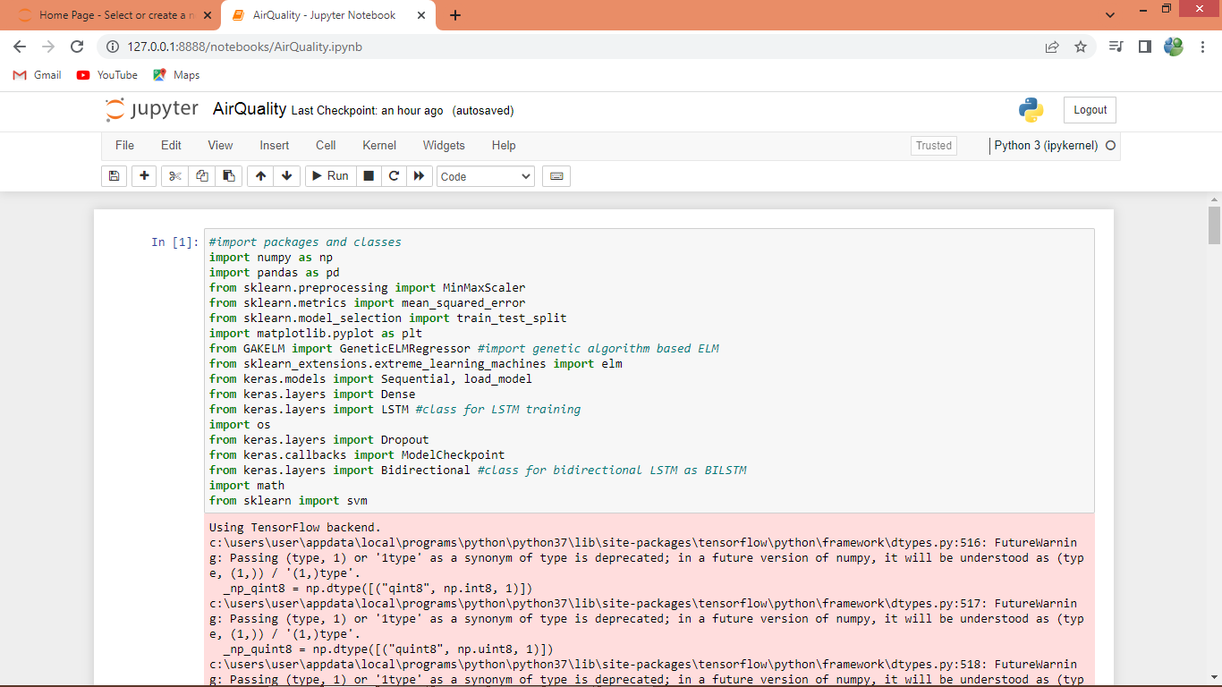
In above screen importing require python classes and packages
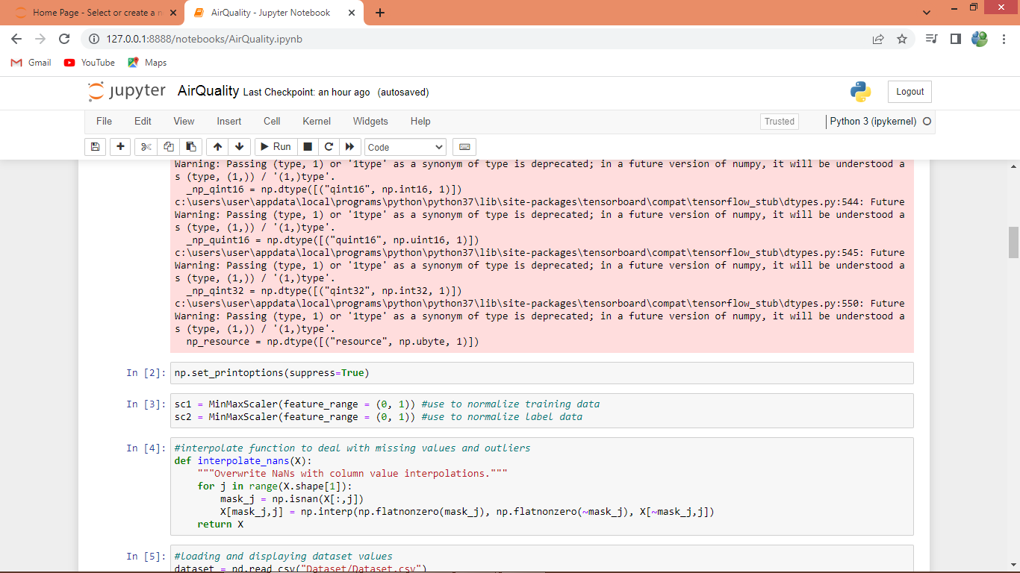
In above screen defining interpolate function to deal with missing values and outliers. Outliers refer to values which are not in normal range so such values will get replace with interpolate and standard deviation.
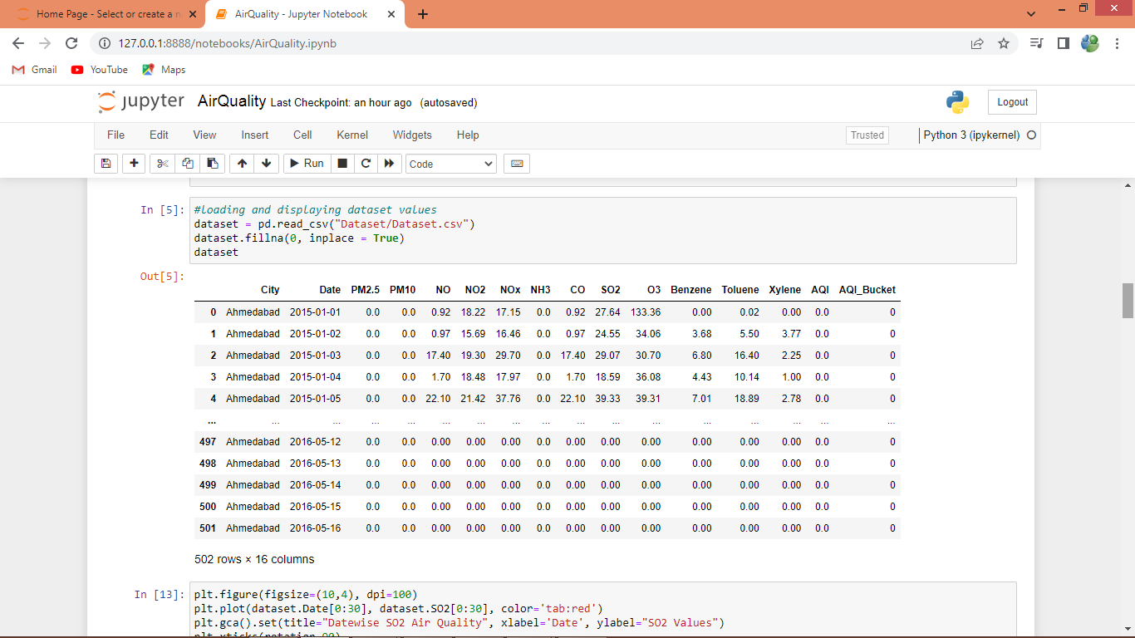
In above screen reading and displaying dataset values
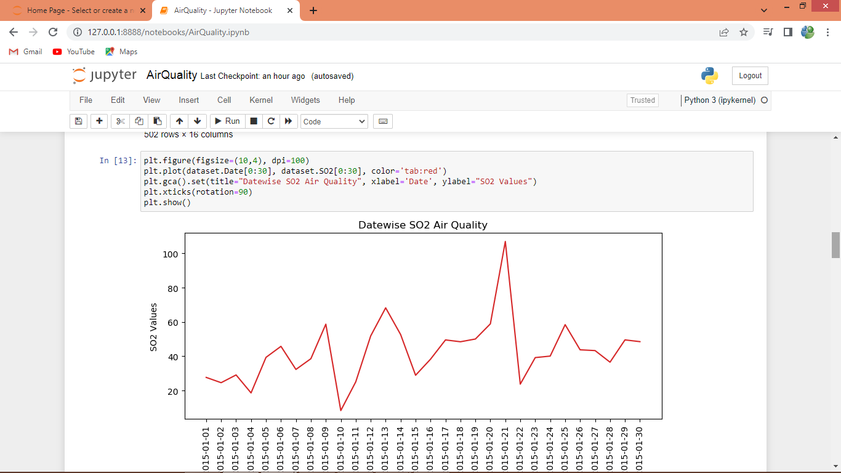
In above graph displaying Air Quality where x-axis represents Date and y-axis represents air quality
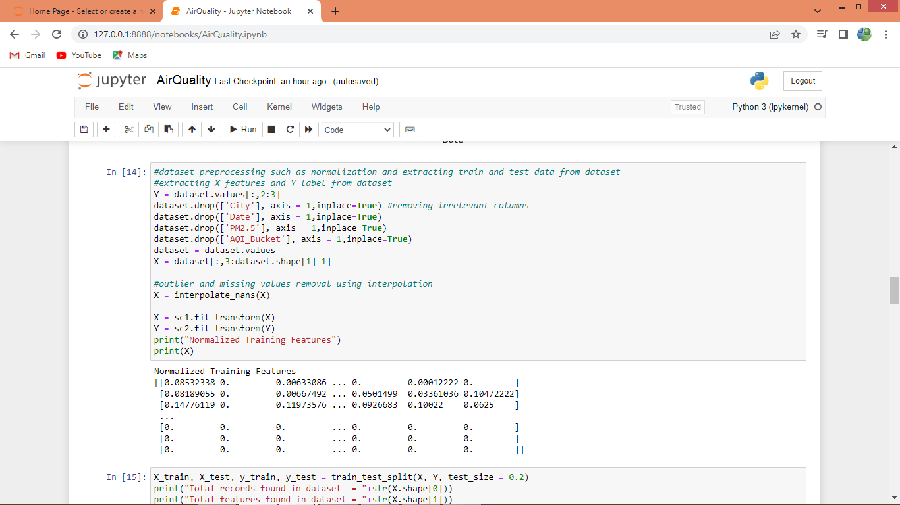
In above screen dataset Pre-processing such as extracting X and Y features, interpolation and normalization
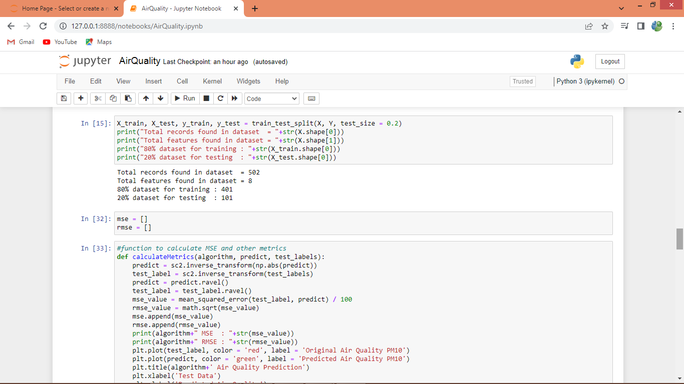
In above screen splitting dataset into train and test and then defining function to calculate MSE and RMSE.
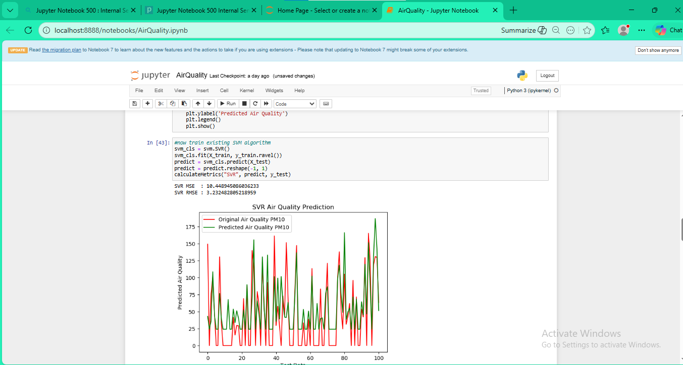
In above screen training SVM algorithm and then with SVM we got 11 as the MSE and in graph x-axis represents TEST COUNT and y-axis represents air quality. Red line represents Original Test Air Quality and green line represents Predicted Air Quality and we can see both lines are closed as they are overlapping with little gaps and this gap can reduce by applying propose algorithm
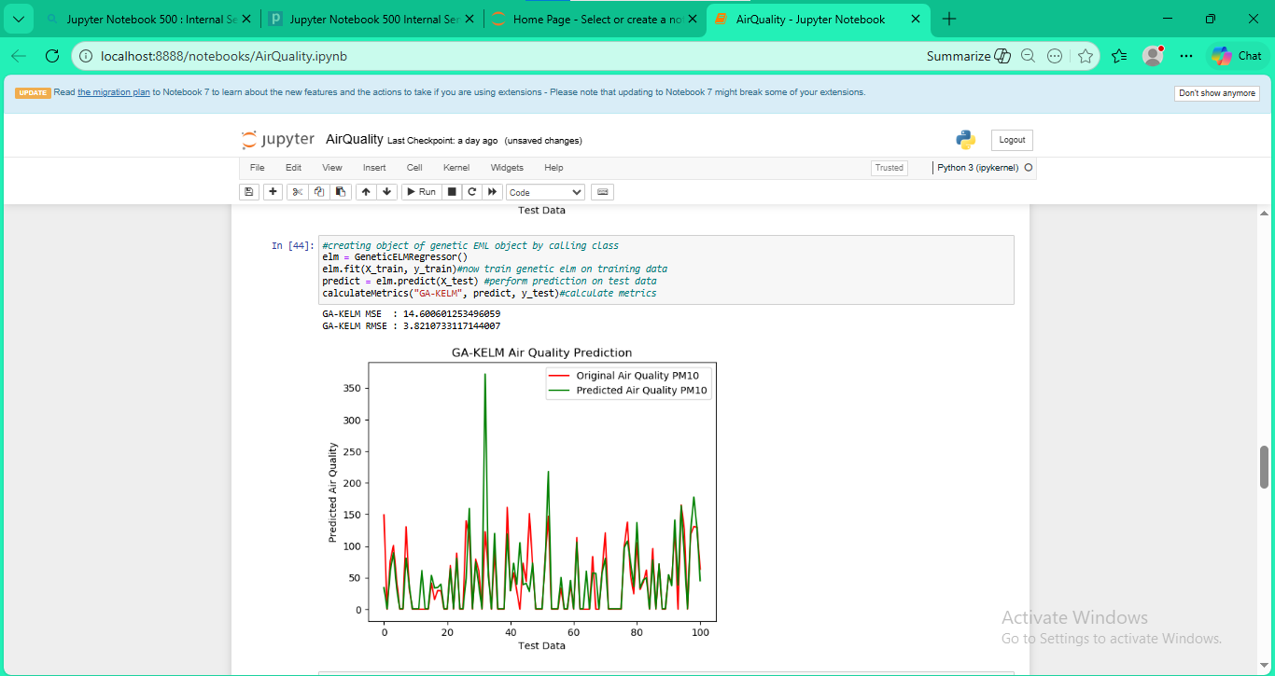
In above screen we are training propose genetic ELM called GA-KELM and we got its MSE as 6 and in graph we can see now both lines are overlap with too few gap.
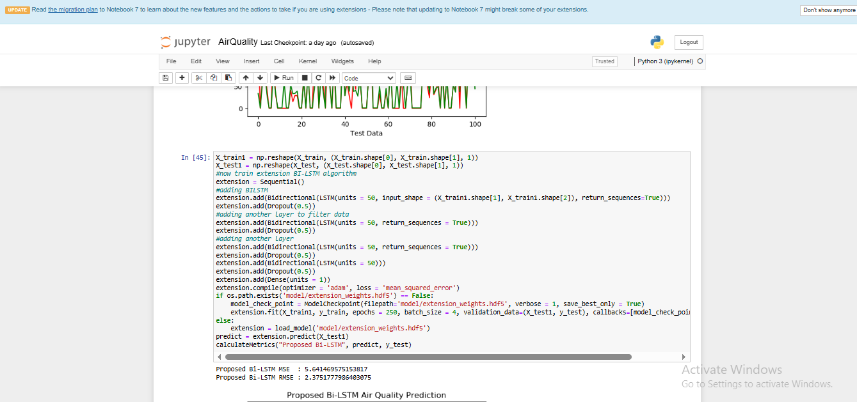
In above screen training extension BI-LSTM algorithm and after executing above block will get below output
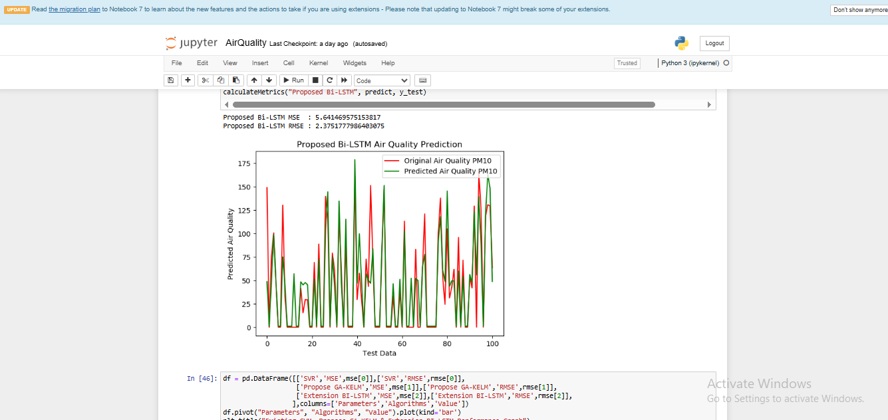
In above screen with extension BI-LSTM we got MSE as 5% and in graph also nearly 90% test and predicted air quality lines are overlapping and in all algorithms extension BI-LSTM has got less MSE and RMSE
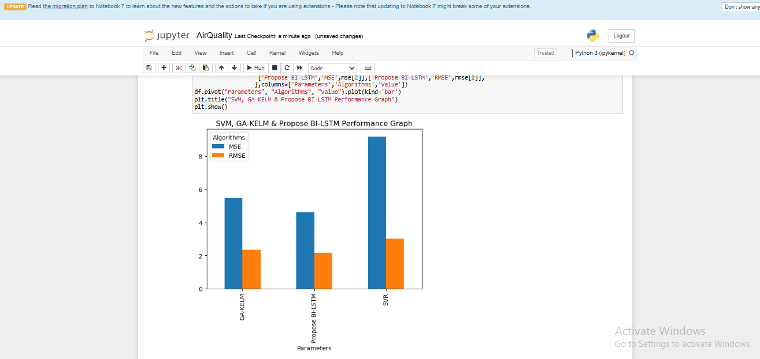
In above graph x-axis represents algorithm names and y-axis represents MSE and RMSE in different colour bars and in all algorithms extension BI-LSTM got less RMSE and MSE
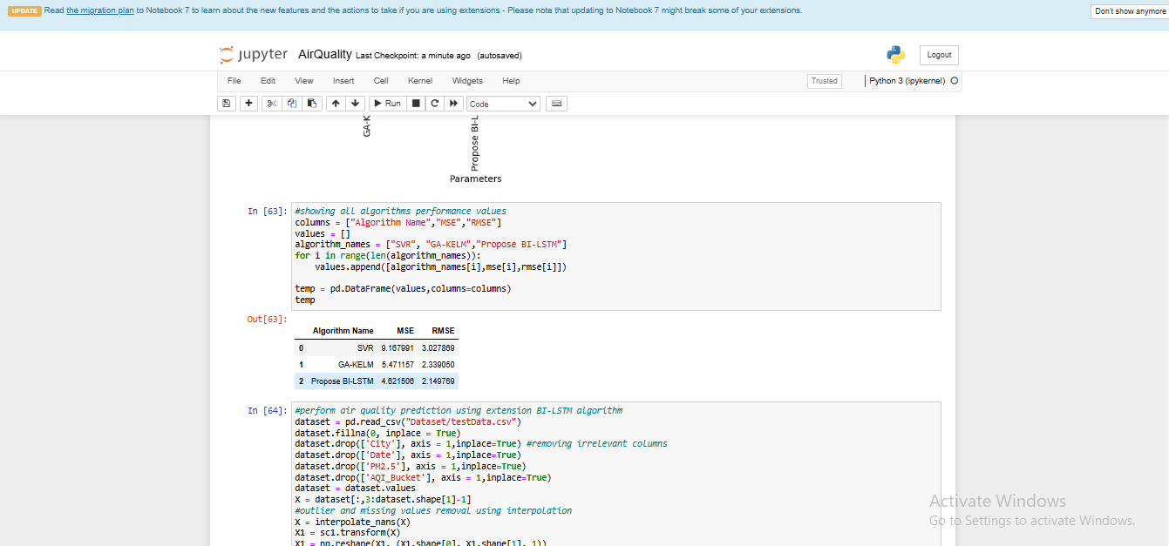
In above screen displaying all algorithms performance in tabular format
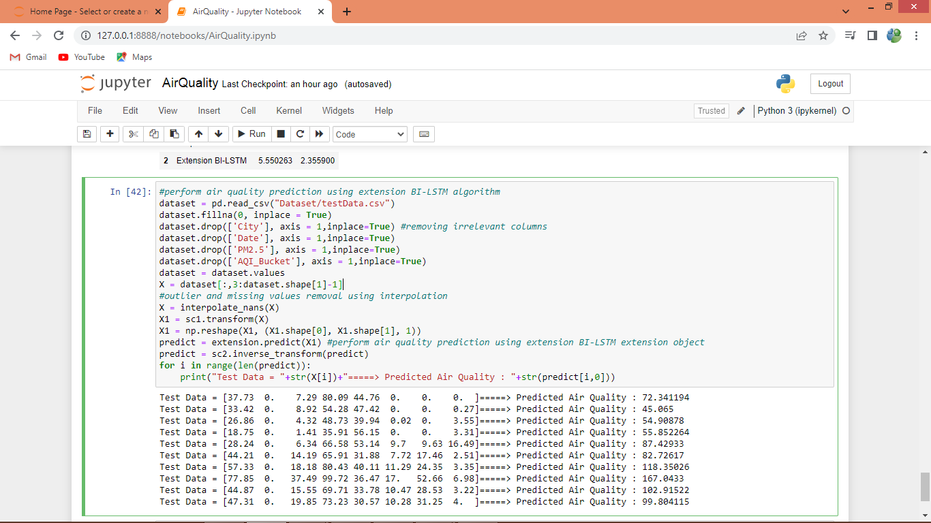
In above screen loading TEST data and then predicting air quality using extension object and then we can see TEST data and predicted air quality after = arrow symbol

8. CONCLUSION:
The economic development achieved by the country through rapid urbanization is polluting the environment in an alarming way and putting people’s lives in danger. Therefore, a correct analysis and accurate prediction of air quality remains a primary condition to achieve the objective of sustainable development. This paper focuses on the problem of prediction model design, and investigates the problems related to the optimization of the model parameters. A GA-KELM model is designed, implemented, and tested. It is experimentally proven to be more efficient than the classical shallow learning and can effectively explore and learn the interdependence of multivariate air quality correlation time series such as temperature, humidity, wind speed, SO2, and PM10. Therefore, the GA-KELM model developed in this study can be used to provide valuable support to vulnerable groups and trigger early warning of adverse air quality events. However, there are still areas for further investigation and improvement. In recent years, numerous advanced algorithms and optimization methods based on genetic algorithms and population intelligence have emerged. Therefore, future research should explore the underlying significance and value of combinatorial intelligence optimization algorithms such as the Limit Learning Machine. Additionally, the issue of manually setting the number of hidden layer nodes in the optimal Limit Learning Machine. Although the Dynamic Extreme Learning Machine (DELM) algorithm offers adaptive determination of hidden layer nodes without human intervention, further work should be dedicated to this aspect. Moreover, to enhance the accuracy and validity of air quality measurement and assessment, it is crucial to integrate pollutant emission factors and meteorological factors into the evaluation system. This integration will enable a more precise and comprehensive evaluation of air quality. In conclusion, our study highlights the significance of the GA-KELM model in predicting air quality. We have addressed the optimization challenges and demonstrated its superiority over traditional methods. However, there is still room for improvement and further research. Future studies should delve into advanced optimization algorithms based on genetic algorithms and population intelligence, explore the potential of the Limit Learning Machine, and strive for adaptive determination of hidden layer nodes. Furthermore, the integration of pollutant emission factors and meteorological factors into the evaluation system will advance the accuracy and reliability of air quality measurement and assessment.
9. REFERENCES:
[1] X. Li, L. Jinn, and H. Kan, “Air pollution: A global problem needs local fixes,” Nature, vol.570, pp.437–439, 2019.
[2] Y. Han, J. C. K. Lam, and V. O. K. Li, “A Bayesian LSTM model to evaluate the effects of air pollution control regulations in China, “in Proc. IEEE Big Data Workshop Big Data AI Air Qual. EstimationForecasting Health Advice, 2018, pp. 4465–4468.
[3] L. Bai, J. Wang, X. Ma, and H. Lu, “Air pollution forecasts: An overview,” Int. J. Environ. Res. Public Health, vol. 15, no. 4, 2018, Art. no. 780.
[4] Y. Ding and Y. Xu, “A Deep Learning Approach to Writer Identification Using Inertial Sensor Data of Air-Handwriting,” IEICE Transient. & Syst., vol. E102-D, no.10, pp.2059–2063, 2019.
[5] S.-Q. Dotes, M. I. Petra, L. Dagger, and L. C. De Silva, “Application of computational intelligence techniques to forecast daily PM10 exceedances in Brunei Darussalam,” Atmos. Pollute. Res., vol. 9, no. 2, pp. 358368,2018.
[6] M. Jia, A. Comelily, Y. Wang, and R. S. Srinivasan, “Adopting Internet of Things for the development of smart buildings: A review of enablingtechnologygives and applications,” Automat. Construct., vol. 101, pp. 111126, May 2019.
[7] Abram, S., Chitra, P., Mahometh, R., Keserwan, S.R., 2020. Hybrid Spatio-temporal Deep Learning Framework for Particulate Matter (PM2.5) Concentration Forecasting.2020 International Conference on Innovative Trends in Information Technology (ICITIIT) 1e6.
[8] Y. Cheng, S. Zhang, C. Huan, M. O. Loudoun, and Z. Lin, “Optimization on fresh outdoor air ratio of air conditioning system with stratum venti-lotion for both targeted indoor air quality and maximal energy saving, “Building Environ., vol. 147, pp. 1122, Jan. 2019.
[9] A. C. Cosmas and R. Simcha, “Machine learning method for real-time non-invasive prediction of individual thermal preference in transient conditions,” Building Environ., vol. 148, pp. 372383, Jan. 2019.
[10] Bhowmik, M., Deb, K., Debnath, A., Asha, B., 2018. Mixed phase Fe 2 O 3/Mn 3 O 4 magnetic nanocomposite for enhanced adsorption of methyl orange dye: neural network modeling and response surface methodology optimization. Appl.Organomet. Chem. 32, e4186 https://doi.org/10.1002/aoc.4186.
[11] Chaudhary, V., Ditchwater, A., Kumar, V., Paul, D., 2018. Time Series Based LSTM Model to Predict Air Pollutant’s Concentration for Prominent Cities in Indium, Aug.
[12] Chen, M., Yang, J., Hu, L., Shamim Hossain, M., Muhammad, G., 2018. Urban healthcare big data system based on crowdsourced and cloud-based air quality indicators. IEEE Commune. Mag. 56, 14e20. https://doi.org/10.1109/MCOM.2018.1700571
[13] Chen, R., Wang, X., Zhang, W., Zhu, X., Li, A., Yang, C., 2019. A hybrid CNN-LSTM model for typhoon formation forecasting. Geoinformatics 23, 375e396. https://doi.org/10.1007/s10707-019- 00355-0.
[14] Du, S., Li, T., Yang, Y., Hong, S.-J., 2019. Deep air quality forecasting using hybrid deep learning framework. IEEE Trans. Knowle. Data Eng. https://doi.org/10.1109/ tkde.2019.2954510, 1-1..
[15] Feng, R., Zheng, H., Gao, H., Zhang, A., Huang, C., Zhang, J., Luo, K., Fan, J., 2019.Recurrent Neural Network and random forest for analysis and accurate forecast of atmospheric pollutants: a case study in Hangzhou, China. J. Clean. Prod.

